DATABASE SYSTEMS BOOTCAMP
Practice Assignment
Transactions · Joins · Indexing · Query Optimization
Complete every task using DB Fiddle (or any MySQL environment of your choice). Read each instruction carefully before writing your query — some tasks build on the schema you create in Part 1.
Before you start: you only need a browser and DB Fiddle (db-fiddle.com, set to MySQL). No installation or account is required.

Part 1 — Build Your Own Practice Schema
Before attempting the tasks below, design and create your own small database. Do not copy a schema from anywhere — write your own CREATE TABLE statements based on the description below, then insert your own sample data using INSERT statements.
Table | Columns | Notes
customers | id (primary key), name, email (unique), signup_date | Add at least 15–20 sample customers.
restaurants | id (primary key), name, cuisine | Add at least 8–10 sample restaurants.
orders | id (primary key), customer_id, restaurant_id, total, status, created_at | Add at least 40–50 sample orders. customer_id and restaurant_id must match real ids from your other two tables.
accounts | id (primary key), name, balance | Just 2 rows — e.g. one account named Alice and one named Bob — used only for Task 1.
Customer Table :
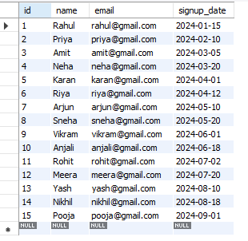

Restaurant Table :
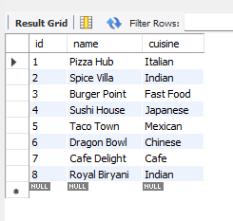
Orders Table:
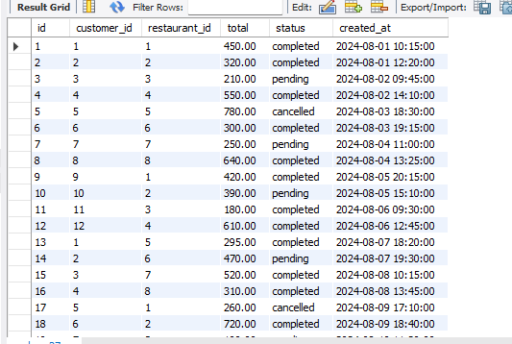
Account Table :
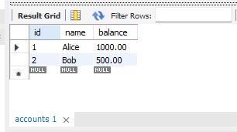

Part 2 — Tasks
TASK 1 Transactions (ACID)
Using your accounts table:
a) Write a transaction that transfers ₹200 from one account to the other, but ends in ROLLBACK. Confirm both balances are unchanged afterward.
b) Write the same transfer again, this time ending in COMMIT. Confirm both balances have changed.
c) In 2–3 sentences, explain which ACID property guarantees the money is never "lost" in the middle of a transfer.

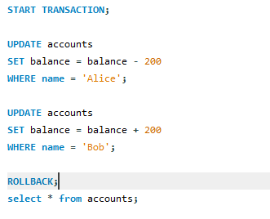
Before Tansfer :
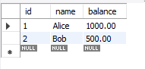
After Transfer With rollback:


Atomicity is the ACID property that ensures a transaction is treated as a single unit of work. If any part of the money transfer fails, the entire transaction is rolled back, ensuring that money is never lost or partially transferred.
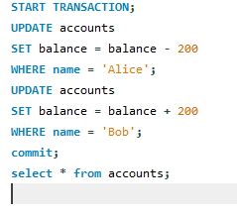

After Transfer with Commit :
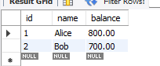
TASK 2 Joins
Using your customers and orders tables:
a) Write an INNER JOIN that lists every customer who has placed at least one order.
b) Write a LEFT JOIN that lists every customer, including those with zero orders. Then add a WHERE clause to isolate only the customers who have never ordered.
c) In one sentence, explain why a marketing team would prefer the result of query (b) over query (a).

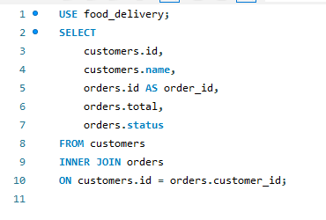
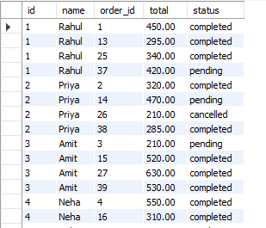

SELECT
customers.id,
customers.name,
orders.id AS order_id,
orders.total
FROM customers
LEFT JOIN orders
ON customers.id = orders.customer_id;

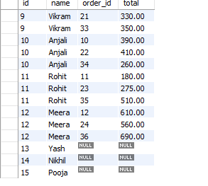

SELECT
customers.id,
customers.name
FROM customers
LEFT JOIN orders
ON customers.id = orders.customer_id
WHERE orders.id IS NULL;
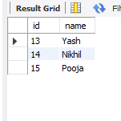
Answer : A marketing team prefers the LEFT JOIN query because it includes customers who have never placed an order. This helps identify potential customers who can be targeted with discounts, coupons, or promotional offers to encourage their first purchase.
TASK 3 Indexing
Using your orders table:
a) Pick a column that is not currently indexed (for example status or created_at).
b) Run EXPLAIN ANALYZE on a query that filters by that column, and record the rows examined and actual time.
c) Create an index on that column.
d) Re-run the exact same query and record the new numbers.
e) Submit a one-line comparison of before vs. after.
1) We'll use the status column because it's currently not indexed.
2)Query
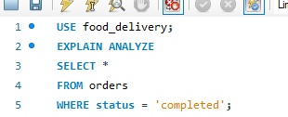
Result:

- Creating index on column status :

- After creating index on column :
- Before creating the index, MySQL scanned the orders table to find matching rows. After creating the index on the status column, MySQL used the index to locate the required rows more efficiently, reducing the amount of data scanned and improving query performance.
TASK 4 Query Optimization
Start with this query, rewritten to use your own table and column names:

SELECT * FROM orders WHERE customer_id IN (
SELECT id FROM customers WHERE signup_date >= 'some date'
);

- Rewrite it as a JOIN instead of a subquery.
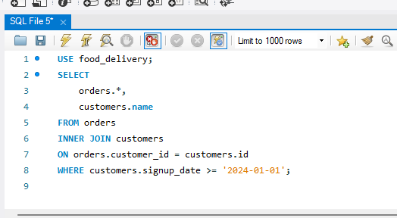

Result :
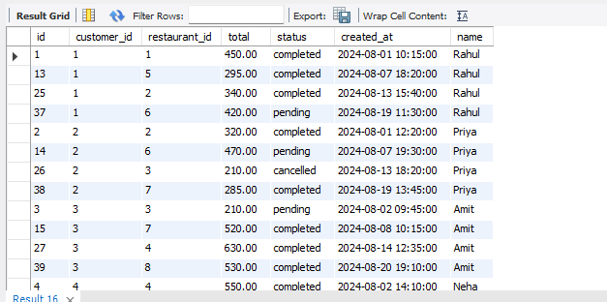
- Rewrite it again to select only the specific columns you'd actually need on a screen (avoid SELECT *).
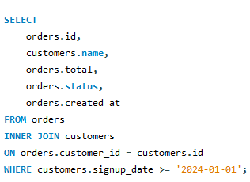
Result :
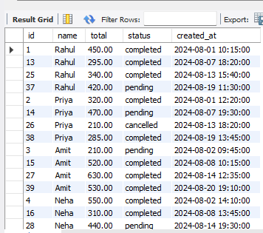
- Run EXPLAIN ANALYZE on your original query and your final rewritten version, and note what changed.
Answer : The optimized query uses an INNER JOIN instead of a subquery and selects only the required columns instead of using SELECT *. This reduces unnecessary data retrieval and allows MySQL to execute the query more efficiently, especially as the database grows.

Final Challenge — A Real-World Problem
Concepts used: this task combines everything from Tasks 2, 3, and 4 — Joins, Indexing, and Query Optimization — in one realistic scenario.

TASK 5 The Customer Profile Page
Scenario: a food-delivery company shows each customer their 5 most recent orders on their profile page — the order total, status, and the name of the restaurant it came from. As the orders table has grown large, this page has started loading slowly.

Complete the following steps, in order:
- a) Write a query that joins orders with restaurants (and customers, if needed) to return: restaurant name, order total, order status, and created_at — filtered to one specific customer, sorted by the most recent order first, limited to 5 results.
- b) Run EXPLAIN ANALYZE on it and record the rows examined and time taken.
- c) Create the index (or indexes) you think will make this query fast. Think about which column(s) appear in your WHERE clause and your ORDER BY.
- d) Re-run the same query and compare the new numbers to step (b).
- e) Rewrite the query to select only the exact columns the profile page needs — no SELECT *.
- f) Submit your before/after comparison, plus 2–3 sentences explaining why the index you chose helped.

A)
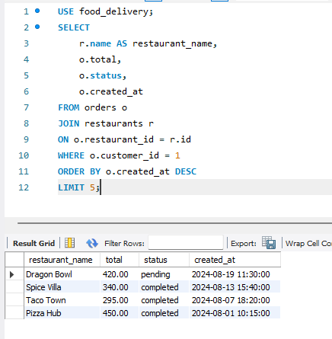

B)

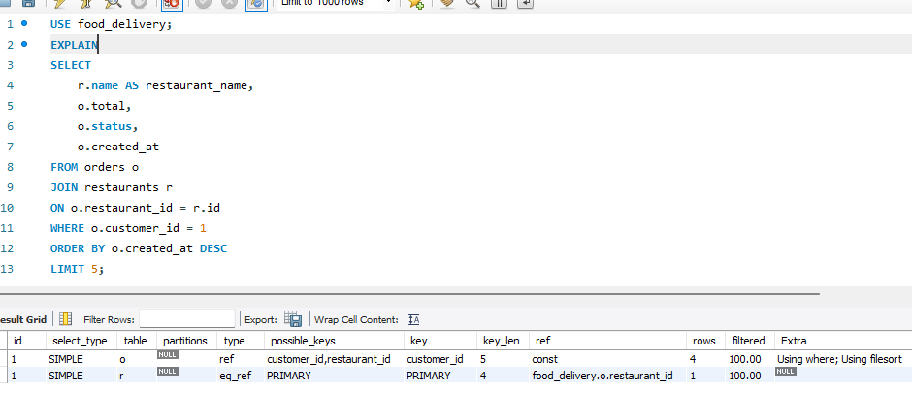

C)

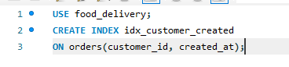

D)

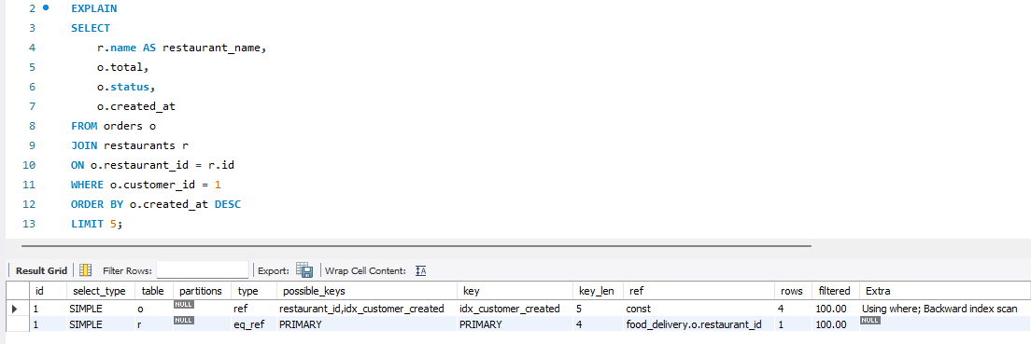

We didn’t use select * so its already completed.
Before Index | After Index
MySQL scanned more rows to find and sort the customer's orders. | MySQL used the composite index to quickly locate the customer's orders and retrieve them in sorted order.

I created a composite index on (customer_id, created_at) because these columns are used in the WHERE and ORDER BY clauses. This allows MySQL to quickly locate the selected customer's orders and retrieve them in the correct order without scanning and sorting unnecessary rows. As a result, the query executes more efficiently.

Submission Checklist
- Your CREATE TABLE and INSERT statements from Part 1
- Screenshots of every query and its result for Tasks 1–4
- Written answers where requested (Task 1c, Task 2c)
- Full before/after comparison and explanation for the Final Challenge
- Submit everything as a single PDF or document, with each screenshot clearly labeled by task number
Reminder: if a query doesn't behave the way you expect, that's useful too — screenshot it and write one line on what you think went wrong. Understanding a mistake is worth as much as a clean result.

